Recipes

You need to add 17 things to this document. (Make sure to number them just as I did in the example.) It may be helpful to copy and paste this list and then fill it in as you go along. All image names must start with your location, e.g yellowstone_sunset.jpg unless you are using a link from the internet.

1. Pork and Peanut Dragon Noodles
2. **Origin**: unknown
3. **Source**: <https://www.budgetbytes.com/pork-peanut-dragon-noodles/>
4. **Category**: Main Dish, Comfort Food, Quick Meal
5. 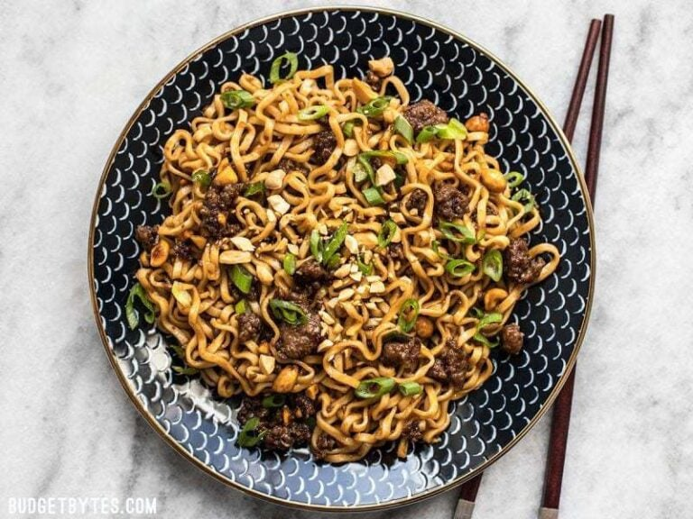
6. <https://www.budgetbytes.com/wp-content/uploads/2018/01/Pork-and-Peanut-Dragon-Noodles-close-768x576.jpg>
7. This meal is a cheap and easy alternative to the classic cheap college meal: ramen noodles. It cooks up in about 10 minutes, and offers a ton of flavor and a more filling alternative to the typical packaged food. There is also plenty of room for culinary freedom and expression by adding extra sauces or spices, and substituting the pork for something like chicken for a healthier protein option.
8. **Recipe Ingredients:**
   1. 1/4 cup chili garlic sauce
   2. 1/4 cup soy sauce
   3. 1/4 cup brown sugar
   4. 1/2 lb. ground pork
   5. 2 3oz. packages ramen noodles (seasoning packets discarded)
   6. 3 green onions, sliced
   7. 1/4 cup unsalted peanuts, chopped
9. **Recipe Steps:**
   1. Combine the chili garlic sauce, soy sauce, and brown sugar in a bowl.
   2. Add the ground pork to a skillet and cook over medium heat until it is fully browned. Once browned, add the prepared dragon sauce and chopped peanuts. Allow the pork and peanuts to simmer in the sauce for another 5 minutes, or until the sauce has reduced by half.
   3. While the pork is browning, begin boiling water for your noodles. Once boiling, add your noodles and cook according to the package directions. Drain the noodles in a colander.
   4. Once the sauce has reduced and the noodles have drained, add the noodles to the skillet and toss until everything is combined and coated in sauce. Top with sliced green onions and serve!
10. **Additional Food images**:
11. <https://www.budgetbytes.com/wp-content/uploads/2018/01/Dragon-Sauce-768x576.jpg>
12. Bowl of sauces mixed together
13. <https://www.budgetbytes.com/wp-content/uploads/2018/01/Reduced-Dragon-Sauce-768x576.jpg>
14. Peanuts and pork cooking in sauce
15. <https://www.budgetbytes.com/wp-content/uploads/2018/01/Pork-and-Peanut-Dragon-Noodles-finished-768x576.jpg>
16. Pork and peanuts being tossed with cooked ramen and green onions
17. Cooper Silhanek